

Nationwide House Energy Rating Scheme® for Existing Homes

Assurance

Strategy

­­­Publication information  
© Commonwealth of Australia 2024

NatHERS for Existing Homes Assurance Strategy is licensed by the Commonwealth of Australia for use under a Creative Commons Attribution 4.0 International licence with the exception of the Coat of Arms of the Commonwealth of Australia, the logo of the agency responsible for publishing the report and some content supplied by third parties. For licence conditions, see [creativecommons.org/licenses/by/4.0](mailto:creativecommons.org/licenses/by/4.0).

All images unless otherwise attributed are from Microsoft 365 Stock Images, used under licence.

**Citation**

DCCEEW (2024). NatHERS for Existing Homes Approach to Assurance, Australian Government Department of Climate Change, Energy, the Environment and Water.

**Disclaimer**

This publication is intended to provide reference material for general information purposes only. It does not constitute legal or other professional advice.

The department disclaims liability, to the extent permitted by law, for any liabilities, losses, damages, and costs arising from any reliance on the information contained in this publication. You should seek legal or other professional advice in relation to your specific circumstances.

# At a glance: Our assurance strategy

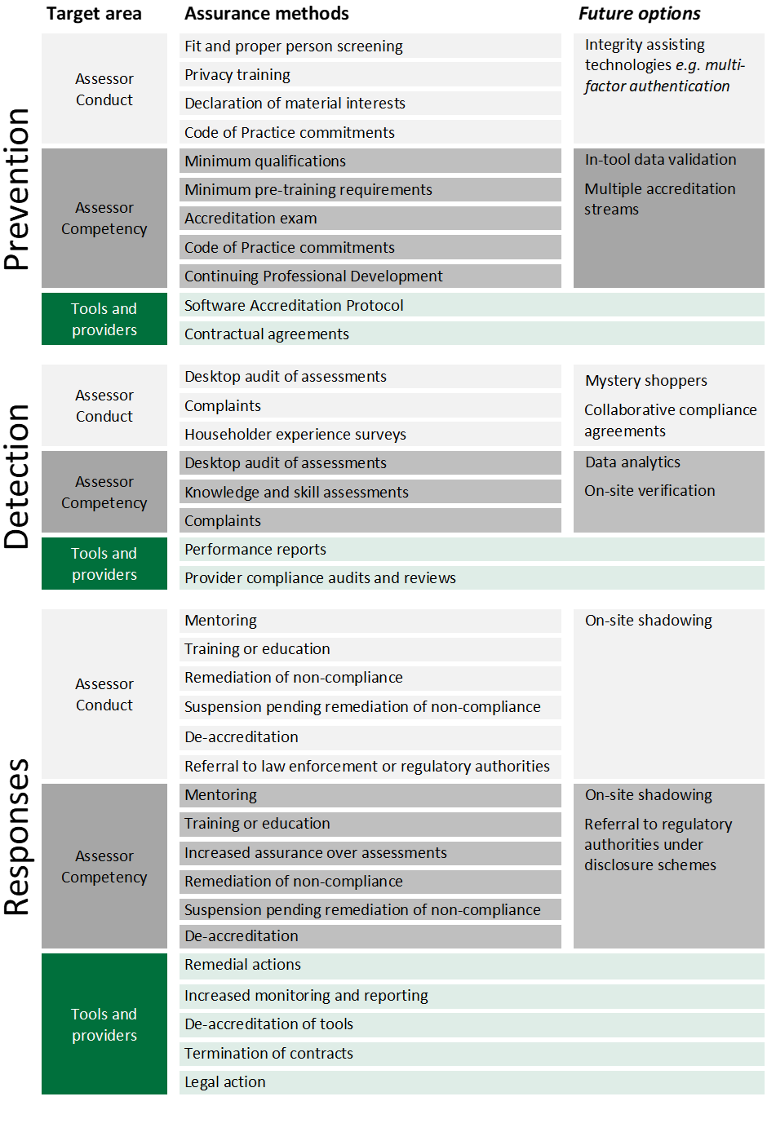

Contents

|  |  |
| --- | --- |
| Purpose | 01 |
|  |  |
| Approach | 01 |
|  |  |
| Assessor accreditation | 02 |
|  |  |
| Independent audit | 03 |
|  |  |
| Ethics and Integrity | 04 |
|  |  |
| Assurance over accredited tools | 05 |
|  |  |
| Assurance over service providers | 05 |
|  |  |
| Management of non-compliance | 06 |
|  |  |
| Continuous improvement of assurance practices | 07 |

# 

# Purpose

The Nationwide House Energy Rating Scheme (NatHERS) is expanding to deliver energy ratings for existing homes.

Assessments of existing homes will require assessors to visit a home to collect information about its internal and external construction, equipment, appliances and surroundings of a home, and input these correctly into accredited software tools to generate an energy rating and certificate.

NatHERS ratings for existing homes will help Australian households better understand their home’s energy performance, identify cost-effective upgrades to improve the comfort of their home, and reduce their energy bills. The ratings will also give banks more confidence to loan capital to Australians to upgrade the energy performance of their homes, and to verify those loans as ‘green’ investments.

The compliance of assessments against NatHERS technical requirements and assessor conduct against codes of practice are essential to enabling the scheme to achieve its objectives.

**This strategy outlines the NatHERS Administrator’s approach to managing the risk of error, non-compliance, fraud, and other misconduct in the delivery of NatHERS energy ratings for existing Australian homes.**

# Approach

The NatHERS for Existing Homes Assurance Strategy ensures that the way we manage errors, non-compliance, fraud, or other misconduct:

* is transparent, impartial, and performed by competent people
* provides timely, credible information to inform decisions
* is adaptable to changes in the scheme and
* compliments but does not duplicate the activities of Commonwealth, state or territory regulators or other compliance and enforcement agencies

This is achieved by working with approved third-party service providers:

* **Software Providers** provide software tools that meet strict technical and functional requirements established by the NatHERS Administrator.
* **Assessor Accreditation Service Providers** accredit assessors in accordance with the requirements set by the NatHERS Administrator and ensure that assessors maintain minimum standards of technical competency and comply with the Assessor Code of Practice.
* **Independent Auditors** provide independent audits using standardised, risk-based processes that have been developed by the NatHERS Administrator to ensure that assessments conform to minimum standards of accuracy.

Software Providers, Assessor Accreditation Service Providers, and Independent Auditors are required to deliver services in accordance with agreed performance and service standards and are accountable to the NatHERS Administrator through reporting and audit processes. ￼

# Assessor accreditation

**All assessors must demonstrate they are competent to ethically and accurately complete a NatHERS assessment, regardless of whether they are collecting data on-site, completing off-site modelling, or both.**

There are significant complexities and risks associated with an existing home assessment.

To be accredited, assessors for existing homes must have minimum specified qualifications and training*, have appropriate insurances, complete a National Police Check, and pass an accreditation exam. To maintain accreditation, assessors must complete continuing professional development (CPD) units and knowledge and skill assessments. These requirements are detailed in the **NatHERS for Existing Homes Assessor Accreditation Requirements**.

|  |  |  |
| --- | --- | --- |
| **Step 1**  **Initial application**  Assessors must demonstrate attainment of minimum qualifications, completion of mandatory training, provide evidence of appropriate privacy management processes, and undertake a fit and proper person check. |  | **Step 2**  **Accreditation exam**  Assessors must demonstrate minimum levels of knowledge and proficiency relating to performing a NatHERS assessment, by passing an accreditation exam. |
|  |  |  |
| **Step 3**  **Accreditation documentation**  Assessors must have appropriate insurance and commit to meet the minimum standards of practice and conduct set out in the Assessor Code of Practice. |  | **Step 4**  **Application review**  Applications are reviewed and if compliant, the assessor is issued an accreditation number and NatHERS accredited assessor identity card.  The assessor accreditation service provider advises applicants how they can rectify non-compliant applications. |
|  |  |  |
| **Step 5**  **Maintaining Accreditation**  Each year, assessors must:   * provide evidence of renewed insurances * achieve minimum CPD requirements * have resolved, or be resolving, identified quality issues * not have an unacceptable history of misconduct. |  | **Step 6**  **Knowledge and skill assessments**  Every three years, assessors must successfully complete a knowledge and skill assessment activity to maintain accreditation. |

* Attainment of 7 units of competency, plus completion of NatHERS for Existing Homes-specific training, and tool-specific training. Different training requirements may apply for assessors who are already part of similar programs, such as the Residential Efficiency Scorecard.

# Independent audit

**Assessments are subject to independent audit to ensure NatHERS assessments for existing homes are reliable and trusted, and to allow compliance risks to be detected and addressed.**

A key element of the assurance process for existing homes is verifying the quality of assessments. Assessments are selected for desktop audit via risk and data-informed indicators and are assessed by independent experts using a standardised methodology in accordance with the **NatHERS for Existing Homes Assessor Audit and Evidence Policy.**

The independent audit process verifies assessment inputs against supporting evidence and confirms that they have been interpreted and applied correctly. Results of the desktop audit are communicated to assessors to support their continuous improvement.

|  |  |  |
| --- | --- | --- |
| **Step 1**  **Selection of assessments for audit**  Assessments may be selected for audit: based on knowledge and skill assessment results; where they contain elements with a high risk of error or significant variations from norms; where a complaint has been received; or there is history of poor performance. |  | **Step 2**  **Independent audit**  Assessments are audited to verify inputs against supporting evidence and technical specifications. They are also checked for compliance with required privacy and conflict of interest requirements. |
|  |  |  |
| **Step 3**  **Audit Report**  Audit outcomes are recorded and reported to the assessor and Assessor Accreditation Service Provider.  Audit Reports detail assessment errors and identify areas for improvement. |  | **Step 4**  **Performance improvement action**  Substantial or repeated quality issues require remediation. Audit Reports may prescribe specific performance improvement actions, with or without suspension, to improve assessment quality and compliance. |
|  |  |  |
| **Step 5**  **Maintaining accreditation**  Assessors must satisfactorily complete all performance improvement actions within required time limits to maintain accreditation. |  | **Suspected serious misconduct or fraud**  From time to time, audits may give rise to reasonable concerns of serious misconduct or fraud. Independent Auditors must report all suspected serious misconduct or fraud to the Assessor Accreditation Service Provider for further investigation. |

# Ethics and integrity

**Assessors must conduct assessments in a manner that prioritises privacy, and engage with householders in respectful, professional and ethical ways.**

Undertaking assessments in private homes can be associated with a range of risks to assessors and householders. Assessors must maintain and comply with practices relating to the collection of data and evidence and maintain privacy obligations.

Assessors must not use their position to mislead or defraud householders or bring NatHERS into disrepute. Assessors must declare material personal interests at accreditation, and appropriately record and manage any conflicts with those interests that arise in assessments they undertake.

|  |  |  |  |  |  |
| --- | --- | --- | --- | --- | --- |
| **Complaints about assessors**  Members of the public can make complaints about assessor conduct.  These complaints are managed in accordance with the **NatHERS Complaints Management Policy**. This ensures that matters raised are resolved at the earliest opportunity and in a manner that is impartial, transparent, and accountable. |  | | **Managing conflicts of interests**  Assessors must declare at accreditation all material personal interests. Where those interests have an actual or potential conflict with an assessment, assessors must declare this to the householder and record the conflict in the assessment data. |  | **Householder experience surveys**  Householder surveys provide a broad view of assessor conduct in practice.  Surveys enquire about aspects of the assessment relating to integrity.  This information is used to identify emerging risks and inform review of assurance settings. |
|  | | | | | |
|  | |  | |  | People must also be able to raise legitimate concerns about the decisions or quality of services delivered by our service providers.  The **NatHERS Complaints Management Policy** describes how complaints can be made about service providers. |

# Assurance over software tools

**The reliability of software tools play a critical role in ensuring that NatHERS ratings are accurate.**

Accredited software tools must meet minimum technical, functional, and operational requirements, and be used by accredited assessors in accordance with specified terms and conditions.

NatHERS for existing homes certificates must only be produced by NatHERS accredited assessors.

|  |  |  |
| --- | --- | --- |
| **Step 1**  **Accreditation of tools**  All tools must be accredited by the NatHERS Administrator in accordance with the **NatHERS Software Accreditation Protocol for Existing Homes.** |  | **Step 2**  **User terms and conditions**  Accredited tool providers are required to impose, and monitor compliance with, minimum terms and conditions for use of accredited tools for the purpose of providing a NatHERS energy performance rating. |

# Assurance over service providers

**Third party organisations approved by the NatHERS Administrator to deliver assessor accreditation, independent audits, and software tools must deliver high quality services to assessors, and effectively fulfil their assurance and compliance functions.**

Assessors must have the opportunity to access clear, timely information that enables their compliance. It is essential that providers deliver services and fulfil their functions to a high standard.

|  |  |  |
| --- | --- | --- |
| **Step 1**  **Appointment of providers**  The NatHERS Administrator appoints third party providers to deliver services.  Applicants undergo due diligence checks, must demonstrate appropriate skills and experience in the relevant function, have appropriate privacy, cyber security, and insurance arrangements, and declare all related business interests.  Approved providers enter into formal agreements with the NatHERS Administrator and agree to key performance measures. |  | **Step 2**  **Performance monitoring and audit**  Providers are required to periodically report on outcomes against performance measures and remedy any performance issues as required by the NatHERS Administrator.  The NatHERS Administrator may verify the compliance of providers with formal agreements and related processes. Verification of service providers is undertaken in accordance with the **NatHERS for Existing Homes Provider Compliance and Performance Management Policy**. |

# Management of non-compliance

**Matters of non-compliance must be addressed quickly and effectively, and in a manner that is proportional to its actual or potential impacts.**

Non-compliance with scheme rules undermines public confidence in NatHERS ratings for existing homes.

Where non-compliance is detected or suspected, service providers must act in accordance with formal agreements and associated processes and cooperate with compliance responses initiated by the NatHERS Administrator.

Management of non-compliance is proportionate to the level of actual or potential harm and considers the behaviour behind the non-compliance. It is guided by the **NatHERS for Existing Homes Assessor Audit and Evidence Policy** and **Assessor Performance Management Policy**.

|  |  |  |  |  |  |  |  |  |  |
| --- | --- | --- | --- | --- | --- | --- | --- | --- | --- |
| Features of non-compliance |  | Response options | | | | | | | |
|  |  |  |  |  |  |  | | |
| **Low level harms**  **Accidental**  **Once-off or infrequent non-compliance**  **Willing to comply** |  | Mentoring |  | Training or education |  | Remediation of non-compliance |  |  | | |
|  |  |  |  |  |  |  |  |  | | |
| **Moderate harms**  **Accidental or opportunistic**  **Repeated non-compliance**  **Reluctance to comply** |  | Mentoring or training or education |  | Disclosure to affected parties |  | Increased assurance over assessments |  | Suspension pending remediation of non-compliance | | |
|  |  |  |  |  |  |  |  |  | | |
| **Major harms**  **Opportunistic or deliberate**  **Repeated non-compliance**  **Refusal to comply** |  | Increased assurance over assessments |  | Disclosure to affected parties |  | Suspension pending remediation of non-compliance |  | Withdrawal of accreditation | | |

NatHERS assessments for existing homes are not underpinned by Commonwealth legislation, and the NatHERS Administrator does not have formal compliance powers such as investigations, penalties, or injunctions.

Where the NatHERS Administrator has information about activity or conduct we believe may be a contravention of a Commonwealth, state or territory law or regulation, the NatHERS Administrator will refer the information to the appropriate law enforcement or regulatory authority for their review.

|  |
| --- |
| **State and territory governments that rely on NatHERS for Existing Homes in regulatory or financial schemes should establish powers to respond to serious non-compliance.**  **Private market products and programs that rely on NatHERS for Existing Homes should establish internal processes to verify the authenticity of the NatHERS certificates they accept.** |



# Continuous improvement

NatHERS for existing homes is committed to ensuring that our assurance practices are responsive to changes in the operating environment. We use data and information to review our assurance settings and make changes that improve the integrity of the scheme and maintain public confidence.

## Data and information sources

|  |  |  |  |
| --- | --- | --- | --- |
| Assessor audit outcomes |  | | Assessor compliance outcomes |
|  |  | |  |
| Complaints |  | | Householder experience surveys |
|  |  | |  |
| Risk assessments |  | | Provider verification and performance reviews |
|  |  | |  |
| Formal reviews, reports, and inquiries |  | Stakeholder engagement | |

|  |
| --- |
| **Our key stakeholders include** |
| State and Territory governments |
| Regulatory authorities |
| Industry groups and peak bodies |
| Registered Training Organisations |
| Software and other service providers |

## Assurance that scales with risk

As demand for assessments for existing homes increases, the risks of non-compliance increase with it. We are continually exploring ways to ensure that our assurance remains fit-for-purpose. Future options may include:

|  |  |  |  |  |  |  |  |  |
| --- | --- | --- | --- | --- | --- | --- | --- | --- |
| **What we are exploring** |  | Agreements with regulators for collaborative compliance |  | In-software tool data validation |  | Integrity supporting technologies e.g., multifactor authentication |  | Public register of accredited assessors |
|  |  |  |  |  |  |  |  |  |
| **Why we are exploring it** |  | Bad operators should not be able to move from one place to another to avoid scrutiny or consequences |  | In-tool validation reduces risks of accidental error, and supports assessor compliance |  | Only accredited people must be able to produce NatHERS certificates |  | Householders should be confident their assessment and rating is provided by an accredited assessor |

