Modelling of Infiltration with Permeability Results for NatHERS Rating

December 2024

1. **Introduction**

The existing Chenath engine V3.23 uses air change per hour (ACH) for input and output for air infiltration calculation when blower-door test result is used. This needs to be modified to align with the National Construction Code which uses permeability for air infiltration. This note details the changes needed in the SCRATCH file for Chenath engine V3.24 to be able to use permeability for air infiltration calculation.

1. **SCRATCH file changes**

In the SCRATCH file, the permeability @50 Pa and the dwelling surface area need to be provided in Section 1.29. Also a new zone type “Garage’ needs to be specified due to its special treatment for permeability calculation. A blower door test is carried out by isolating the dwelling from the garage if the garage is unconditioned, while it is carried out by connecting the dwelling with the garage if the garage is conditioned.

Section **1.29 Sub-type 29: Blower door test input (Optional)**

|  |  |  |
| --- | --- | --- |
| **Column** | **Format** | **Value** |
| 1-2 | I2 | 1 |
| 3-5 | I3 | 29 |
| 9-14 | F6.0 | ACH @50 Pa. Blower door test result of air change per hour at 50 Pa. Default 10.0. |
| 15-20 | F6.0 | Pressure exponent obtained by blower door test. Default 0.65. |
| 21-26 | F6.0 | Permeability @50 Pa. Blower door test result of air leakage per hour per m2·surface area at 50 Pa (m3/m2·hr).  Note: If both ACH and permeability entered, permeability will be used by the Chenath engine. |
| 27-32 | F6.0 | Dwelling surface area (m2). |
| 194 | I1 | Flag to switch on infiltration calculation without using blower door test results.  0: use blower door test results for infiltration calculation.  1: ignore blower door test results for infiltration calculation. Infiltration calculation based on component input. |

Section **3.1 General**

Since a garage zone will need to be treated differently for permeability calculation, the SCRATCH file needs an indicator for the Garage zone type. If the zone type is Garage, the zone type in the SCRATCH file should be named as “Garage”.

|  |  |  |
| --- | --- | --- |
| **Column** | **Format** | **Value** |
| 1-2 | I2 | 3 |
| 3-5 | I3 | Zone number (1-150) |
| 9-23 | A15 | Zone name |
| 24-29 | F6.0 | Zone volume (m3) |
| 30-35 | F6.0 | *A* for infiltration rate (air changes per hour). Must be zero if zone volume is zero. |
| 36-41 | F6.0 | *B* for infiltration rate (air changes per hour). Must be zero if zone volume is zero. May be set to zero if a constant rate is required. |
| 42-47 | F6.0 | Terrain factor for this zone* (multiplies wind speed for infiltration and ventilation calculations for this zone. However, the maximum of the set of zone terrain factor values is used in the calculation of sol-air temperatures). |
| 48-53 | A6 | Zone type. Used to trigger special treatment of roofspaces, sub-floor spaces, basement car park and corridor, garage and horizontal or inclined air gaps. The only valid values are (description in brackets):  **Normal** (any zone other than the following six types)  **AirGpT** (top surface of a horizontal or inclined air gap)  **RoofSA** (Air in a roof space)  **SubFlA** (Air in a sub-floor space)  **BaCP00** (Basement car park zone)  **Corrid** (Corridor zone)  **Garage** (Garage zone) |
| 54-59 | I6 | Flag to indicate whether the fractions of solar heat gain allocated to each opaque surface in this zone are to be obtained directly from specified values (see sections 3.3 – 3.7), or are to be estimated by the engine.  0: use specified values  1: estimate the values |
| 60-65 | I6 | Only used if zone type is not ‘Normal’. Enter associated zone numbers according to zone type as follows:  If zone type = AirGpT: enter zone number of bottom surface of this air gap  If zone type = RoofSA: enter zone number of top of ceiling surface for this roofspace  If zone type = SubFlA: enter zone number of underside of floor for this sub-floor space |
| 66-71 | I6 | Only used if zone type is not ‘Normal’. Enter associated zone numbers according to zone type as follows:  If zone type = AirGpT: leave blank  If zone type = RoofSA: enter zone number of under-roof surface for this roofspace  If zone type = SubFlA: enter zone number of top of ground surface for this sub-floor space |
| 72-77 | F6.0 | Only used if zone type is RoofSA or SubFlA.  Enter effective emissivity for this roofspace or sub-floor space. |
| 78-83 | I6 | Flag to indicate whether this zone’s temperature is written to the temperature file (see section 1.9)  0: Write the temperature  1: Do not write the temperature |

1. **Dwelling surface area**

The dwelling surface area is the inside wall/ceiling/floor surface area as illustrated in Figure 1 for dwellings with an unconditioned garage. As shown in Figure 1, the internal wall to the unconditioned garage is included in the dwelling surface area calculation. For dwellings with a conditioned garage, the external wall of the conditioned garage is included in the dwelling surface area calculation as shown in Figure 2.

It should be noted that:

1. The internal wall thickness is not included in the wall area calculation as shown in Figure 1, which is consistent with the existing wall/ceiling/floor area calculation.
2. Ceiling to roof space is included. Cathedral and racked roofs are included. Floor to subfloor zone is included. Slab on ground floor of zones (exclude unconditioned garage zone) is included. However, ceiling/floors between different levels of the same dwelling is not included.
3. Wall area is the gross wall area including opening/window area (i.e. not net wall area). Likewise, the ceiling/roof area is the gross area including skylights and roof-windows..
4. For apartments, the wall/ceiling/floor to neighbour zones are included.
5. For apartments, the surface area should include the internal walls/ceilings/floors from the apartment in consideration to the shared corridor zone and the floor to the shared basement carpark or garage zone as shown in Figures 3 and 4. Internal walls to roof space and subfloor are included.
6. For an unconditioned garage zone, the internal wall, floor or ceiling to the garage zone should be accounted for in the surface area. In this case, the floor to ground, the roof and the external wall of the unconditioned garage zone should not be accounted for in the surface area.
7. For a conditioned garage zone, the surface area is calculated by treating this conditioned garage zone as a normal habitable zone such as a bedroom zone.
8. **Infiltration assumptions in the Chenath engine**

Considering that the existing NatHERS tools have already had an infiltration calculation method for garage zones, the infiltration calculation for an unconditioned garage zone will remain the same as per the current calculation method.

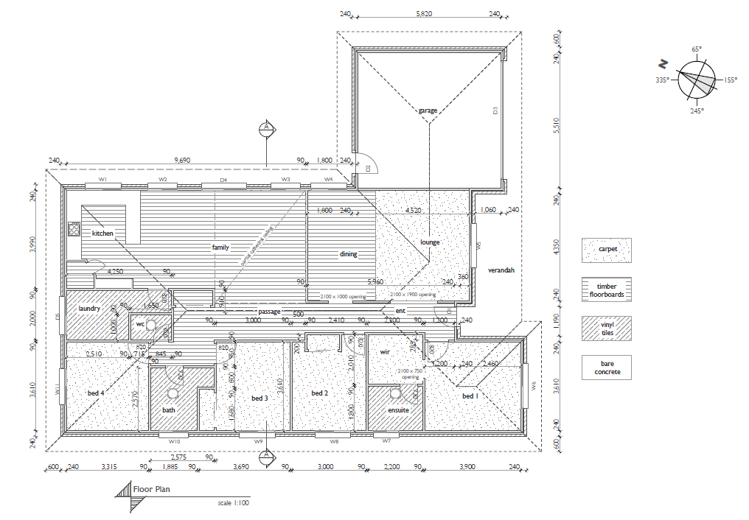

Figure 1. Wall surface area for dwellings with an unconditioned garage.



Figure 2. Wall surface area for dwellings with a conditioned garage.

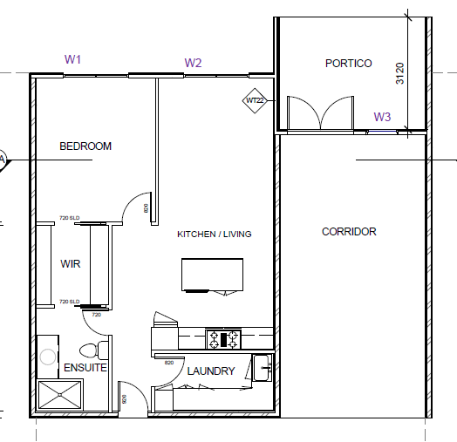

Figure 3. Wall surface area for apartments with a corridor zone.

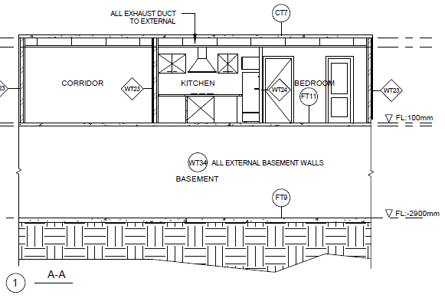

Figure 4. Wall/floor/ceiling surface area for apartments with a corridor zone and a basement carpark.